Supplement E: Results with Hydrologic Benefit Function based on Chinook juveniles per spawner
Claire Kouba
2026-03-10

1 Methodological details of Hydrologic Benefit function formulations (Supplements B-E)
The Hydrologic Benefit (HB) function is intended to estimate the ecological value (in units of fish production) provided to fish by specific flow values (e.g., timing of fall flow increase; magnitude of dry season flow). This is expressed in conceptual mathematical terms as $fish=b+m_{1}*flow_{1}+m_{1}*flow_{2} ⋯$; see methods in Kouba et al. (2025) for more details. It’s important to note that, in this dataset, only 40-60% of variation in fish outcome was explained in models based on flow data, and the HB function does not constitute a prediction of the number of fish outmigrating in a given year.
Specifically, the results below are based on statistical models, using LASSO regression, of reproductive output for two species of salmon (coho and Chinook) in the Scott River stream system. Reproductive output is expressed in units of outmigrating juvenile abundance and normalized juveniles-per-adult spawner; two reproductive units for two species yields the four HB function formulations.
While MARSS models were used as a tool for identifying important functional flows in (Kouba et al. 2025), they are unsuitable for this hydrologic scenario outcome forecasting purpose, due to the nature of autoregression: the forecasting of future fish outcomes requires historical observations of fish outcomes. Therefore, to use MARSS models in estimating the ecological effects of flow changes under different management scenarios, it would be necessary to have historical fish records collected in an alternate reality under the different management scenarios, which is not possible. Similarly, LASSO models which included spawner abundance as a predictor were also not included in this exercise.
Consequently, only LASSO models dependent on hydrologic variables were evaluated as potential tools to forecast the outcomes of flow change on fish reproduction.
For each species, across all statistical methods, the coefficients for any single predictor were consistently negative or positive; e.g., more coho reproduction was consistently associated with earlier fall reconnection.

2 HB coefficients, component contributions, and annual values
Table 1: Coefficients for the Hydrologic Benefit function, an emperical estimate of ecological services provided to Chinook salmon by specific functional flows. The predicted value is in units of log10(juveniles per spawner) produced, modeled using only hydrological factors.
Predictor | Value | Greater Hydrologic Benefit value associated with
Intercept | 1.944 | Intercept Term
s1_SP_ROC_Max | -0.041 | Slower max. rate of change, spring recession (as outmigrating smolt)
w1_Wet_BFL_Mag_50 | -0.181 | Smaller wet season baseflows (as eggs and hatchlings)
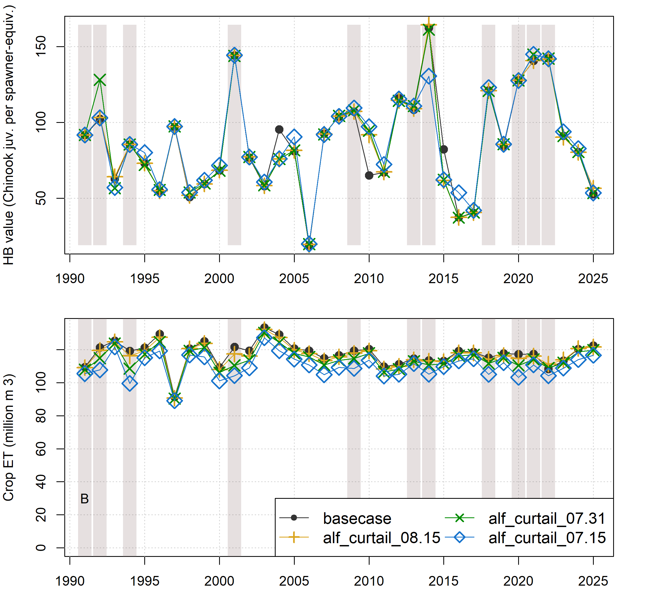
Figure 1: Comparison of annual performance in two objective functions (Hydrologic Benefit and ET, representing environmental and agricultural objectives, respectively) for brood years 1991-2025. The scenarios pictured are basecase (black circles) and a scenario from each of three categories: Enhanced Recharge, Crop Change, and Native Vegetation (Low ET). Dry-type water years (vertical bars) are 1991, ’92, ’94, 2001, ’09, ’13, ’14, ’18, and ’20-’22.
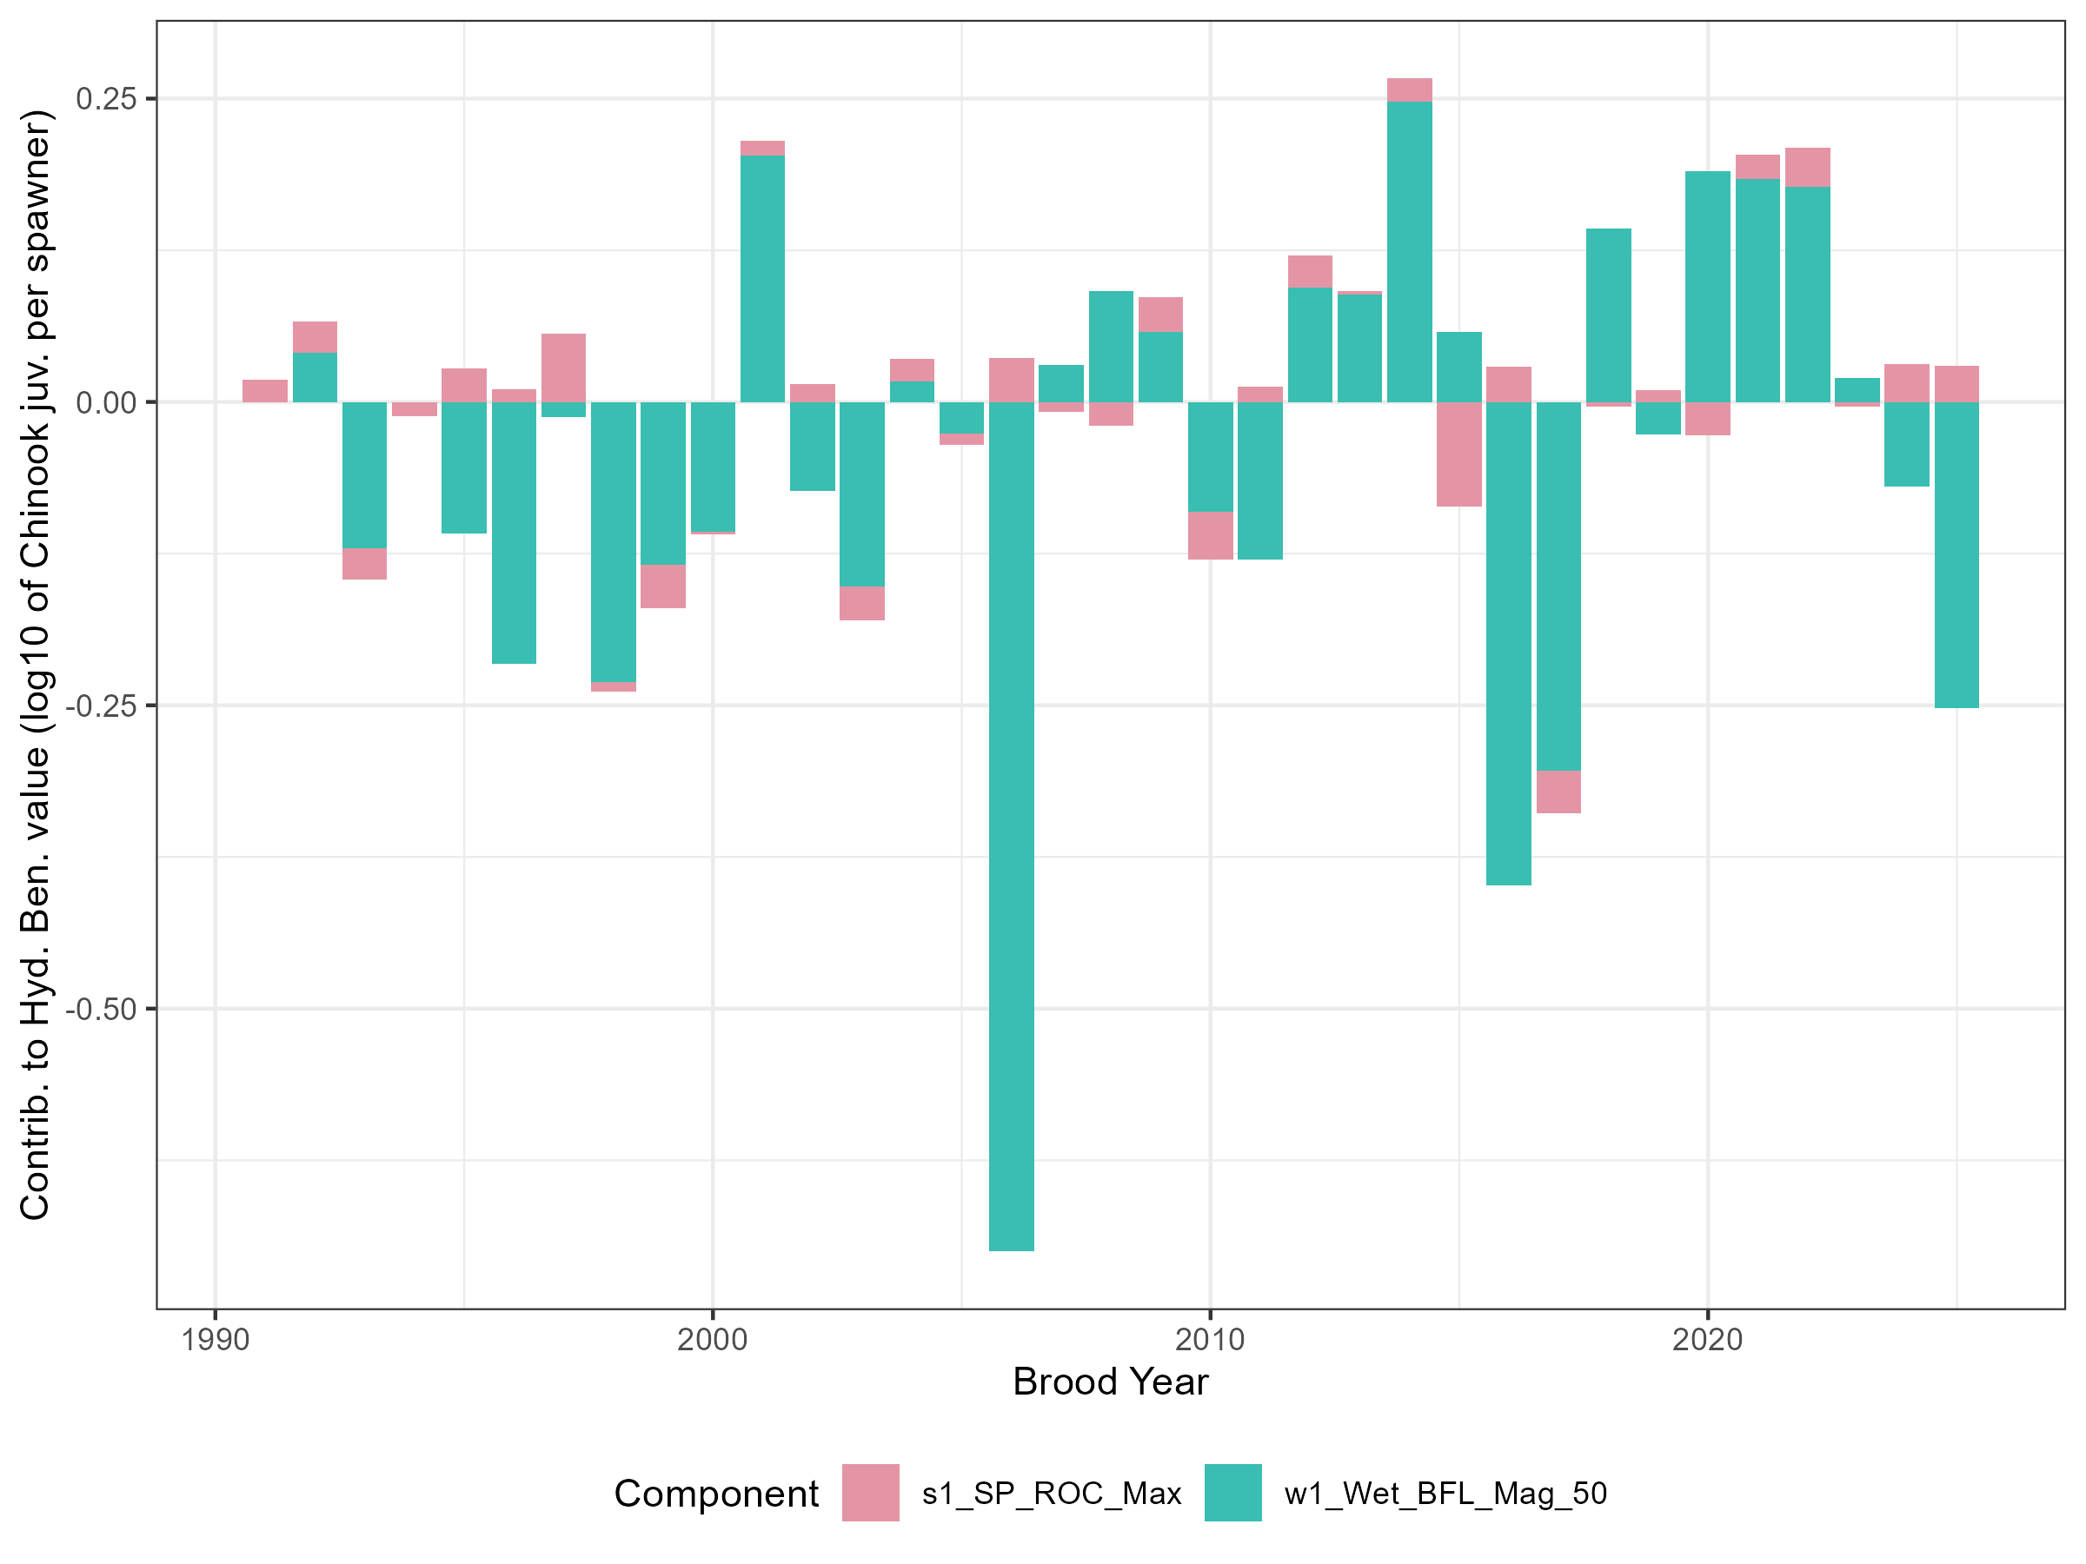
Figure 2: For the basecase scenario, contributions to annual Hydrologic Benefit function values, by functional flow metric (see Table 1 above; intercept values not shown).

3 Trade-offs and efficiency
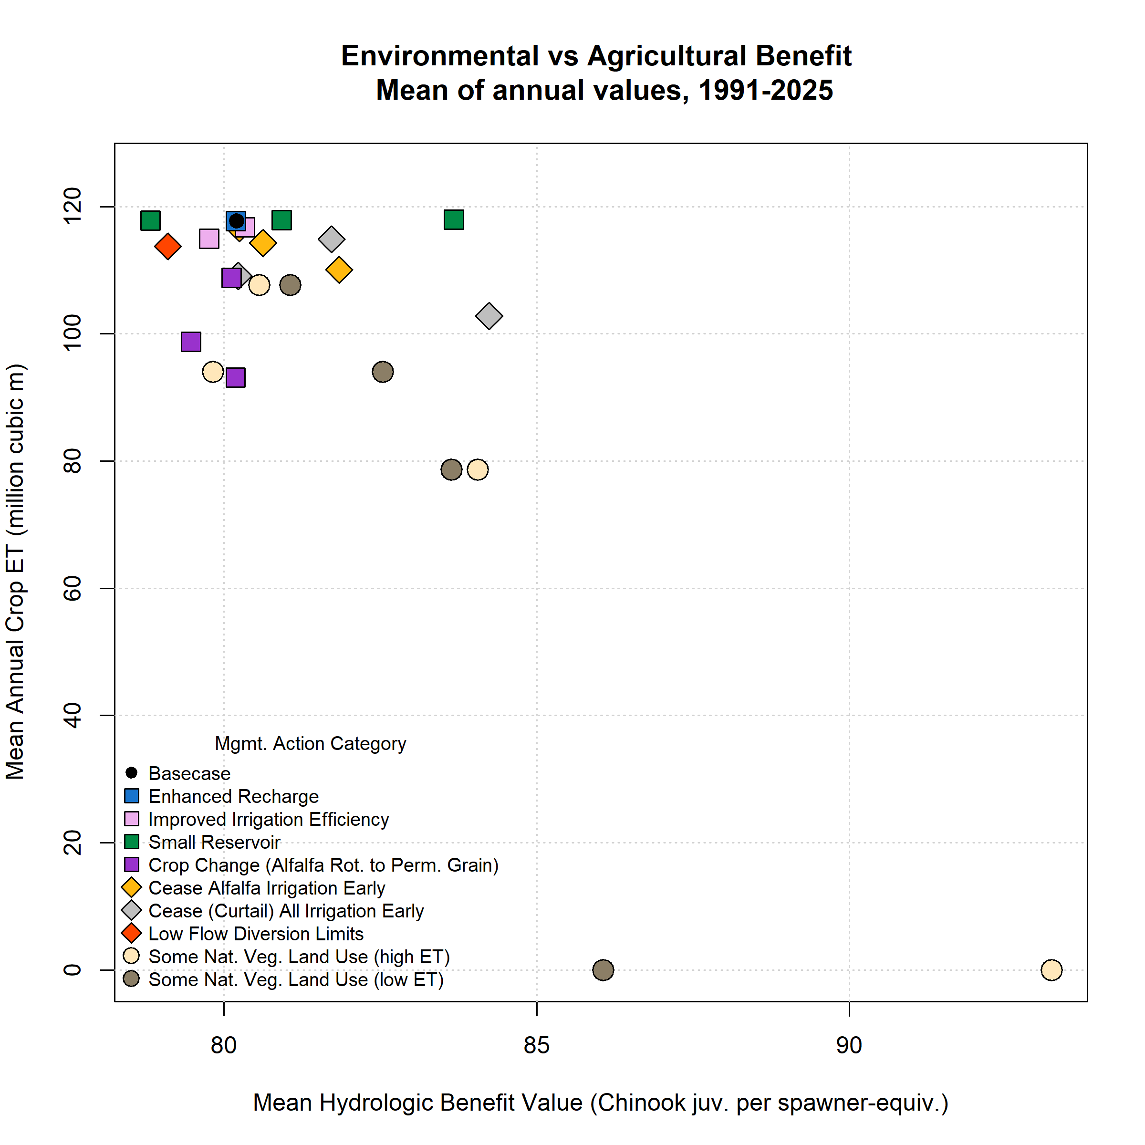
Figure 3: Environmental and agricultural objective function performance (in terms of Hydrologic Benefit, or HB, value; and crop ET volume) for basecase (black circle in upper left) and 25 management scenarios. Symbol x and y coordinates are the average of 35 annual HB and ET values for each scenario over the full model period (water years 1991-2025); for exampe time series of annual values, see previous figure.
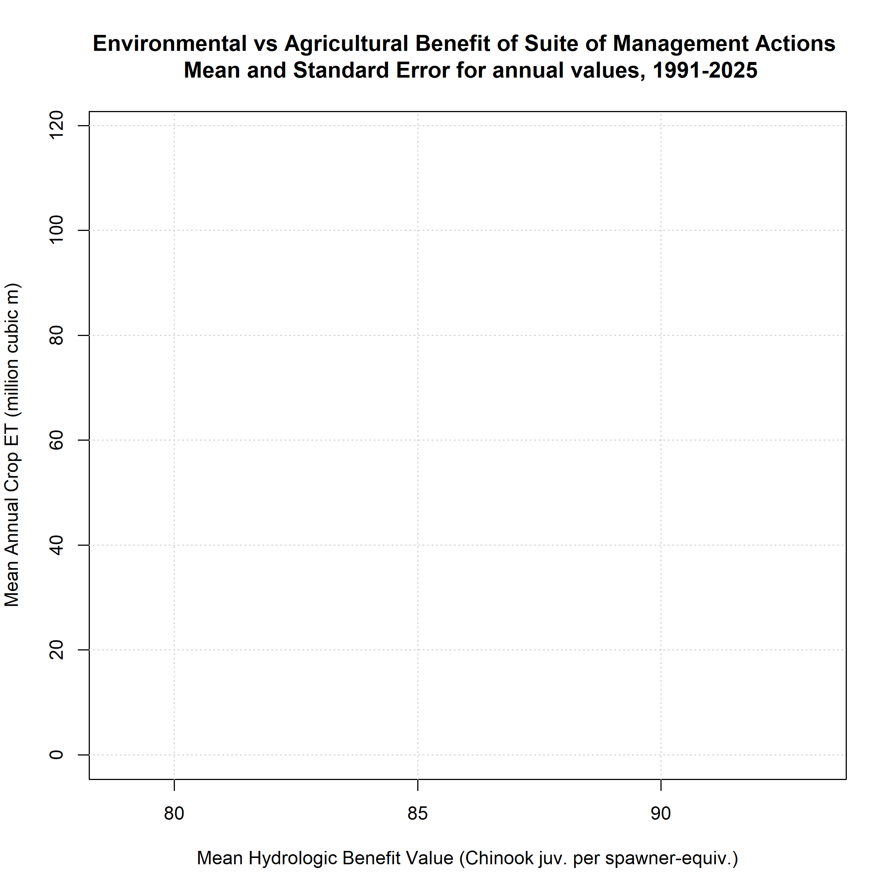
Figure 4: Scenario trade-off efficiencies, or average Hydrologic Benefit value (a proxy for environmental benefit) gained per crop ET value lost (a proxy for farmer cost) (normalized to average basecase HB and ET values, respectively), in all 35 years. Some scenarios are excluded if they have no or negative ET loss, producing infinite or negative efficiency values.

4 Three objectives and Pareto-optimal set
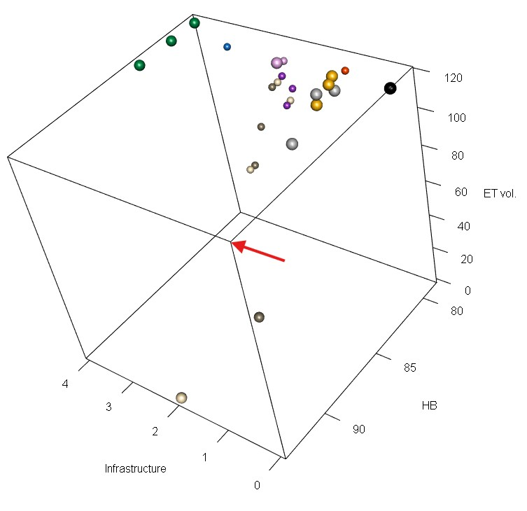
Figure 5: A three-dimensional scatter plot of the objective function values for basecase and 24 management scenarios, averaged over 35 water years (1991-2025). Larger spheres are shown for the Pareto-optimal set of scenarios. Scenario colors correspond to legend in Supplement Figures 3 and 4. The corner corresponding to optimal values of all objective functions (the ‘best’ corner) is highlighted with a red arrow.

5 Scenario Results Table
Table 2: Scenario attributes for 25 scenarios. Values in the Mean Hydrologic Benefit (HB) and Mean ET columns are averages of 35 annual values for each scenario. Efficiency not calculated for scenarios with no average ET loss.
Scenario ID | Category | Feas. | Mean HB | Mean ET | Pareto | Efficiency
basecase | basecase | 0 | 80.20 | 117.76 | Yes | --
alf_curtail_07.15 | AlfIrr | 1 | 81.84 | 110.09 | Yes | 0.31
alf_curtail_07.31 | AlfIrr | 1 | 80.63 | 114.26 | Yes | 0.18
alf_curtail_08.15 | AlfIrr | 1 | 80.25 | 116.61 | Yes | 0.06
curtail_all_07.15 | Curtail | 1 | 84.24 | 102.83 | Yes | 0.4
curtail_all_07.31 | Curtail | 1 | 80.23 | 109.13 | Yes | 0
curtail_all_08.15 | Curtail | 1 | 81.72 | 114.91 | Yes | 0.78
eflows25_div_lims | FlowLims | 1 | 79.11 | 113.75 | -- | --
grain_12k | CropCh | 2 | 79.48 | 98.75 | -- | --
grain_14k | CropCh | 2 | 80.19 | 93.16 | -- | --
grain_6k | CropCh | 2 | 80.12 | 108.81 | -- | --
irr_eff_0.1 | IrrEff | 2 | 80.33 | 116.74 | Yes | 0.19
irr_eff_0.2 | IrrEff | 2 | 79.76 | 114.98 | -- | --
maxMAR_fields2024 | EnhRch | 3 | 80.19 | 117.75 | -- | --
natveg_high_12k | NatVegH | 2 | 84.05 | 78.66 | -- | 0.14
natveg_high_4k | NatVegH | 2 | 80.56 | 107.70 | -- | 0.05
natveg_high_8k | NatVegH | 2 | 79.83 | 94.02 | -- | --
natveg_high_all | NatVegH | 2 | 93.23 | 0.00 | Yes | 0.16
natveg_low_12k | NatVegL | 2 | 83.63 | 78.66 | -- | 0.13
natveg_low_4k | NatVegL | 2 | 81.06 | 107.70 | -- | 0.13
natveg_low_8k | NatVegL | 2 | 82.54 | 94.02 | -- | 0.14
natveg_low_all | NatVegL | 2 | 86.06 | 0.00 | Yes | 0.07
reservoir_etna | Res | 4 | 80.92 | 117.87 | Yes | --
reservoir_french | Res | 4 | 78.83 | 117.84 | Yes | --
reservoir_shackleford | Res | 4 | 83.67 | 117.98 | Yes | --

6 Functional Flow Metrics
Annual values of the functional flow metrics highlighted in this Hydrologic Benefit function are tabulated below. The basecase and alfalfa irrigation scenarios are used as examples; for a graph of each scenario’s impact on simulated Fort Jones daily average flow, see Supplement E, Figure 2.

Table 3: For functional flow s1_SP_ROC_Max: Annual functional flow values, for example scenarios, based on simulated Fort Jones daily average flow, which influence Hydrologic Benefit Function results.
brood_year | basecase | alf_curtail_08.15 | alf_curtail_07.31 | alf_curtail_07.15
1991 | 0.155 | 0.155 | 0.155 | 0.155
1992 | 0.141 | 0.140 | 0.140 | 0.139
1993 | 0.243 | 0.242 | 0.242 | 0.241
1994 | 0.216 | 0.216 | 0.216 | 0.216
1995 | 0.137 | 0.137 | 0.137 | 0.134
1996 | 0.171 | 0.171 | 0.171 | 0.170
1997 | 0.081 | 0.080 | 0.079 | 0.079
1998 | 0.208 | 0.187 | 0.155 | 0.165
1999 | 0.263 | 0.263 | 0.263 | 0.235
2000 | 0.197 | 0.197 | 0.202 | 0.180
2001 | 0.168 | 0.168 | 0.166 | 0.164
2002 | 0.162 | 0.163 | 0.163 | 0.163
2003 | 0.247 | 0.247 | 0.247 | 0.216
2004 | 0.155 | 0.154 | 0.155 | 0.153
2005 | 0.210 | 0.210 | 0.210 | 0.182
2006 | 0.119 | 0.119 | 0.119 | 0.119
2007 | 0.208 | 0.208 | 0.209 | 0.209
2008 | 0.231 | 0.231 | 0.231 | 0.209
2009 | 0.136 | 0.139 | 0.135 | 0.122
2010 | 0.269 | 0.270 | 0.268 | 0.246
2011 | 0.166 | 0.166 | 0.166 | 0.156
2012 | 0.140 | 0.140 | 0.141 | 0.130
2013 | 0.186 | 0.186 | 0.186 | 0.186
2014 | 0.155 | 0.144 | 0.160 | 0.164
2015 | 0.363 | 0.364 | 0.365 | 0.365
2016 | 0.134 | 0.134 | 0.136 | 0.134
2017 | 0.262 | 0.262 | 0.262 | 0.234
2018 | 0.199 | 0.199 | 0.199 | 0.199
2019 | 0.172 | 0.172 | 0.172 | 0.172
2020 | 0.246 | 0.246 | 0.246 | 0.246
2021 | 0.152 | 0.154 | 0.130 | 0.130
2022 | 0.127 | 0.136 | 0.136 | 0.136
2023 | 0.199 | 0.201 | 0.201 | 0.176
2024 | 0.129 | 0.134 | 0.135 | 0.114
2025 | 0.133 | 0.133 | 0.133 | 0.133

Table 4: For functional flow w1_Wet_BFL_Mag_50: Annual functional flow values, for example scenarios, based on simulated Fort Jones daily average flow, which influence Hydrologic Benefit Function results.
brood_year | basecase | alf_curtail_08.15 | alf_curtail_07.31 | alf_curtail_07.15
1991
1992 | 607 | 600 | 368 | 601
1993 | 1,003 | 980 | 1,114 | 1,107
1994
1995 | 973 | 972 | 988 | 876
1996 | 1,238 | 1,235 | 1,223 | 1,219
1997 | 738 | 737 | 736 | 737
1998 | 1,275 | 1,275 | 1,275 | 1,264
1999 | 1,038 | 1,036 | 1,030 | 1,027
2000 | 970 | 967 | 966 | 939
2001 | 206 | 207 | 211 | 211
2002 | 888 | 879 | 880 | 881
2003 | 1,082 | 1,078 | 1,072 | 1,073
2004 | 665 | 911 | 910 | 907
2005 | 771 | 764 | 764 | 687
2006 | 2,432 | 2,405 | 2,392 | 2,383
2007 | 631 | 633 | 636 | 636
2008 | 481 | 478 | 475 | 504
2009 | 564 | 559 | 556 | 557
2010 | 930 | 563 | 533 | 531
2011 | 1,027 | 1,023 | 1,023 | 960
2012 | 474 | 488 | 488 | 490
2013 | 489 | 483 | 466 | 466
2014 | 96 | 96 | 98 | 318
2015 | 565 | 871 | 861 | 860
2016 | 1,689 | 1,690 | 1,693 | 1,305
2017 | 1,455 | 1,445 | 1,444 | 1,443
2018 | 355 | 356 | 357 | 338
2019 | 773 | 760 | 758 | 758
2020 | 238 | 238 | 240 | 241
2021 | 254 | 250 | 250 | 249
2022 | 270 | 265 | 262 | 262
2023 | 658 | 667 | 657 | 655
2024 | 878 | 874 | 871 | 868
2025 | 1,328 | 1,250 | 1,310 | 1,309

Kouba, Claire, Leland Scantlebury, Jason Wiener, Sarah Yarnell, and Thomas Harter. 2025. “A Watershed-Specific Approach to Identify Key Functional Flow Metrics Supporting Salmon Reproduction.” Ecohydrology : Ecosystems, Land and Water Process Interactions, Ecohydrogeomorphology 18 (5): e70098. https://doi.org/10.1002/eco.70098.

